

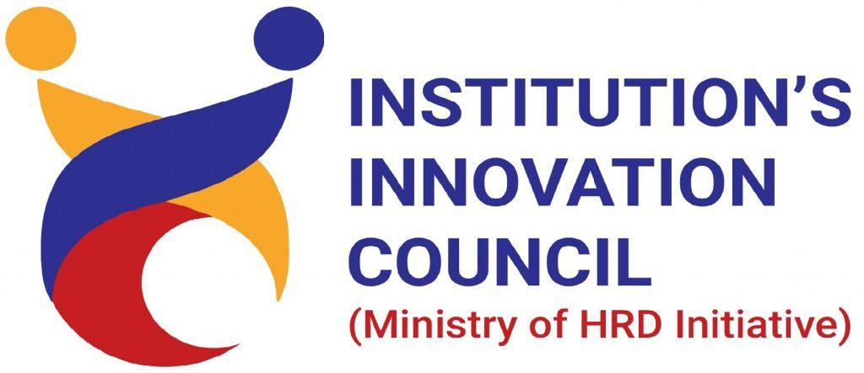

Certiﬁcate of Participation

This is to certify that SUSARITHA M, SONA COLLEGE OF TECHNOLOGY has successfully participated in one week online FDP on “Effective and Instructive Research” from 11 May - 15 May,2020 organised by Department of Civil Engineering, Sona College of Technology, Salem.



Co-ordinator HoD/Civil